**Gustavus Children’s Enhancement Program**

**The Rookery at Gustavus**



**Strategic Plan**

**Adopted May 19th, 2019**

**Updated 2024**

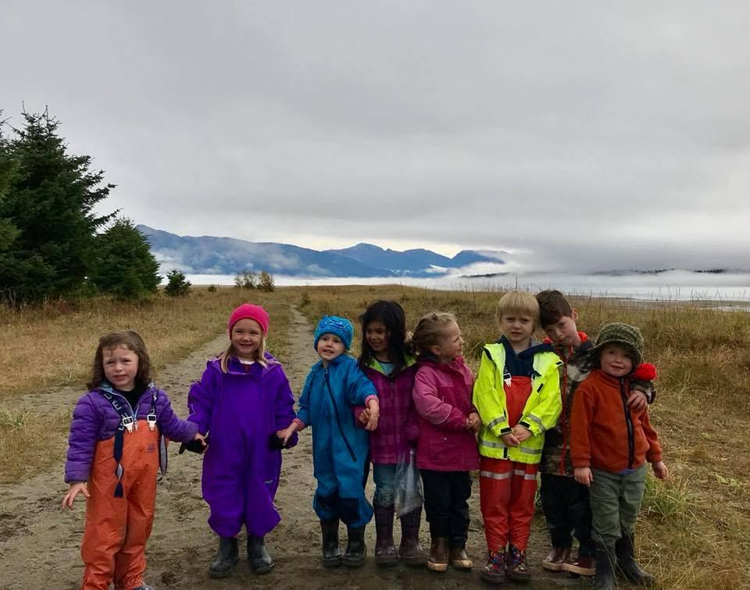

**“Wilderness and Wonder”**

**Table of Contents**

1. **About this Strategic Plan**
2. **About Our Organization: Gustavus Children’s Enhancement Program**
3. Mission Statement
4. Vision Statement
5. Tagline
6. Values
7. Goals and Objectives
8. **About Our Operation: The Rookery at Gustavus**
9. Parent Membership and Board Makeup

1. Organizational Chart & Staffing as of May, 2019
2. Payroll Hours Detail for Calendar Year 2018
3. **Strategic Plan**
4. Goals and Objectives
5. Timeline
6. Fair Market Wage Data
7. Logic Model

1. **About this Strategic Plan**

This is the first strategic plan written for Gustavus Children’s Enhancement Program organization at The Rookery at Gustavus facility. This plan was originally adopted at the May, 2019 Board Meeting. Upon adoption, the content herein is intended to be referenced frequently, revisited annually, amended annually if needed, and re-worked every five years. In 2024, the board reworked the Strategic Plan. Changes made are noted and explained where necessary.

1. **About Our Organization: Gustavus Children’s Enhancement Program**

The Gustavus Children’s Enhancement Program (GCEP) was established in 2007 as a private nonprofit 501(c)(3) exclusively for charitable, scientific and educational purposes, more specifically to house the Gustavus Community Preschool (GCP) and other childhood development programs. From establishment in 2007 until 2014, GCEP was a small, informal volunteer-based parent-cooperative, and GCP was the sole program offered. During that time, the organizational structure consisted of seven volunteer board members and one employee – the Preschool Teacher.

This informal structure worked quite well. With no oversight from the State of Alaska, the Preschool Program operated with untrained but passionate teachers, involved parents and community members. When needed, it was common for the teacher to bring in a substitute teacher of their own choosing which may be the next parent who walked in the door to drop off their child, if they were available. When there was no running water, teachers would bring buckets of water from home. Families paid what they were able to, if and when they could and invoices were not created.

In 2012, the board learned of the need to be certified by the Department of Education and Early Development (DEED) in order to continue offering preschool services. Certification was obtained with no issues. In 2014, GCEP chose to become a licensed child care center in order to be eligible for participation in state and federal assistance programs and funding opportunities which weren’t otherwise available. Volunteer board members took on the task of bringing GCEP up to compliance with the rules and regulations pertaining to the Alaska Department of Health and Social Services (DHSS) Child Care Program Office (CCPO) including: AS 47.32.010, AS47.32.900 Centralized Licensing and Related Administrative Procedures; 7 AAC 57.010 – 7 AAC 57.990 Child Care Facilities Licensing; and 7 AAC 10.010 - 7 AAC 10.9990 Licensing, Certification and Approvals.

It was quickly learned that the continuous administrative workload of being a licensed facility was unreasonable to expect volunteers to maintain long-term. At that same time, in early 2015, DEED announced that all private preschool programs were henceforth required to follow the DHSS CCPO licensing rules and regulations. Although 7 AAC 57.015 lists some exemptions from licensure requirements, those exemptions do not allow the GCEP Preschool Program to continue to operate without either requiring all parents to attend at all times or limiting enrollment to a maximum of only four children. This requirement to be licensed paired with the increased administrative cost to be licensed meant GCEP’s operation was unsustainable.

In response, GCEP started a new program: year-round, full-time (except during the Preschool Program) Child Care. This new program not only met a demand in the community, it also supported the newly increased infrastructure of GCEP as a licensed facility. Without this new program, it was hard to justify such a significant administrative workload for just a 9-hour/ week seasonal program. Additionally, staff had historically had little-to-no early childhood education and had only continued employment with GCEP for up to one school year at a time. This norm could not continue under licensing requirements, but adding the Child Care Program offered staff more hours for the amount of education and continuing education required of them.

In 2016, GCEP started paying for administrative functions for the first time, and in 2017 GCEP approached the City of Gustavus for help to become sustainable. Although the Child Care Program itself essentially breaks even in terms of program staff vs. program income, but neither the Child Care Program nor the Preschool Program accounts for the cost of the overhead and administrative cost of running a licensed facility.

In 2018, GCEP (both preschool and child care) became a contracted limited social service of the City of Gustavus. Under City policy and procedure, the Gustavus City Council must review, at our discretionary request, our annual business plan and budget request from GCEP and may choose to provide funding of up to 20% of GCEP’s operating budget for that year. See city code Chapter 6.06 – Social Services. GCEP Board chose to drop the name “Gustavus Community Preschool” and replace it with “The Rookery at Gustavus” under which the “Preschool Program” and “Child Care Program” would fall.

In 2020 – Our program closed for a short time due to lack of kids and staff because of illness. Fears of COVID kept us from reopening, and when the board felt comfortable reopening, we lacked the appropriate insurance to do so. The board opted to remain closed for the short term, and Chatham expressed interest in pursuing a grant to undertake preschool operations themselves. Our board and administration worked closely with Gustavus School’s Principle and the Superintendent of Chatham to ensure a seamless preschool transition from GCEP to Chatham. The board considered our mission of providing preschool to all preschool aged children fulfilled. There remained the issue of COVID as well as a need for child care. The board changed over many times, and no solutions to the problems emerged.

In 2021 and 2022 – Our bylaws were adjusted to accommodate a lack of board members, so we could remain in good standing with oversight agencies while essentially defunct. Our small, hard-working board continued to fundraise and advocate for the continuation of the Rookery.

In 2023 – We were granted ownership of the Gustavus Clinic building, and were able to use the money we had fundraised in the last 3 years to put toward a renovation of the building.

In 2024 – As of February, the building is nearly completed, and we are program planning! The board re-evaluated this document based on present need in Gustavus. Changes made to our bylaws include a return to an older standard of board direction, as well as the departure from a heavy reliance on parent volunteerism and necessity for parent membership and voting. Our early history as a parent cooperative was based on the belief that our children thrive in a dynamic environment driven by involved parents, creative staff, and a supportive community. As we have grown, much of the need for day to day volunteerism has shifted. We encourage parent involvement, offer courses for staff and volunteers in order to propel our mission, and offer child care in trade for parent engagement. We recognize families have limited time and capacity, and want our program to offer peace and stability to families, without the stress of “mandatory volunteerism”, while maintaining abundant opportunities for parent and family involvement and input.

1. **Mission Statement**

*The Rookery fosters learning for all ages through play-based exploration, rooted in outdoor engagement, drawing inspiration from Waldorf, Classical, and Unschooling Education models, offering programming for young children, support for homeschoolers, and additional opportunities for public school students.*

1. **Vision Statement**

We envision opportunities for children, families, staff, and community to grow and learn in a safe, nurturing environment with secure emotional attachments, nourishing foods prepared by ourselves, and ample opportunities and resources to inspire creativity, wonder, and joy, indoors and out.

“Undistracted time to study what is most worthwhile, usually with good friends, in a beautiful place, with nourishment.” -Aristotle

1. **Tagline**

Wilderness and Wonder

1. **Values**

Primary focuses in our mission:

1. Emotional and Physical Safety
   1. Communication styles that promote age-appropriate emotional autonomy are taught and used
   2. Growing awareness of the individual’s “felt sense” (Felt sense is defined as the ability to connect body and mind for a holistic sense of self, deepening our relationships and ability to tend to self, others, and the world around us)
   3. Sensible precautions for potentially dangerous activities
2. Nurturing
   1. Adults can be relied on for emotional connections
   2. Children are encouraged to experience, express, and remedy/process their needs and emotions with adult support
   3. A focus on nutrient dense foods that sustain children through the day and offer opportunities for children to connect with each other, their families, their community, and the environment through traditional, local, and nutrient-dense foods.
3. Community-building
   1. Support for social and emotional growth that leads to long-lasting healthy relationships between peers, adults, and community members.
4. Alternative Learning Models
   1. Inspiration from Waldorf, Classical, and Unschooling Education models that foster and encourage a childs’ inherent drive to learn (See attached Program Planning, Resources Document)
   2. Multi-age, play-based learning. This is sometimes referred to as unschooling, self-lead learning, or the Sudbury model.
   3. Theatre, Art, and Music – dramatic imaginative play, artistic expression, and music benefit mind, body, and soul.
   4. Character building - Nurturing a strong sense of self and good character
   5. Outdoor education has been, and remains a primary focus. Children thrive in an outdoor schooling model, and it fits so seamlessly into our Gustavus lifestyle.
   6. Local history – a sense of place and belonging strengthens individuals and communities. We work to incorporate geographic and social history, knowledge of local plants, people, and resources into our day to day.
   7. Engaging the broader community with education opportunities

1. **About Our Operation: The Rookery at Gustavus**

We are incorporated under the name Gustavus Children’s Enhancement Program, a not-for-profit 501(c)3, doing business as The Rookery. The Board of Directors oversees the Learning Center and is pursuing licensing for the Child Care Program.



1. **Board Makeup and Cultivation**

GCEP shall be governed by a Board of Directors consisting of at least 3, but not more than 7 members. The offices of President, Vice President, Secretary, and Treasurer shall be elected or appointed by the board. First year board members may not hold offices, unless by unanimous consent in the case of a major board member deficit. Current board will cooperatively seek new members. Prospective board members can approach current board members, who can take the name of the candidate to the board for discussion and potential formal invitation. When the current board reaches a consensus, an invitation is extended to the prospective new board member. Our board members may also hold paid positions within the organization.

1. **Organizational Chart**

|  | GCEP Board of Directors | | | |  |  |  |  |  |  |
| --- | --- | --- | --- | --- | --- | --- | --- | --- | --- | --- |
|  |  |  |  |  |  |  |  |  |  |  |
|  |  | Administrator | | | |  |  |  |  |  |
|  |  |  |  |  |  |  |  |  |  |  |
| Non-Program Volunteers | | | |  |  |  |  |  |  |  |
|  |  |  |  |  |  |  |  |  |  |  |
|  |  |  |  | Program Director | | |  |  |  |  |
|  |  |  |  |  |  |  |  |  |  |  |
| Program Leads | | Child Care Associates | | Caregivers | | Interns | | Program Volunteers | |

1. **Strategic Plan**

1. **Ongoing Goals & Objectives in 2024 (in no particular order)**

**Organizational Goals**

**Goal 1:** Create and sustain a work environment that facilitates a large pool of qualified employees, and promotes employee satisfaction, retention, and high qualifications.

* Clear and intentional communication
* Pursue employee benefit options
* Ensure at least one qualified substitute is on staff
* Provide regular opportunities for communication between staff and administration
* Provide regular opportunities for pay increases as staff reach milestones
* Provide clear expectations of staff education and development milestones
* Create a coherent, clearly organized entity (GCEP)

**Goal 2:** Ensure consistent, year round programs for all children

* Hire a qualified administrator
* Hire sufficient, qualified staff
* Intentionally and thoughtfully transition into and out of breaks and lapses in programming and other potentially disruptive time periods

**Goal 3:** Develop and maintain a sustainable financial model

* Charge a fair market rate that ensures we remain operational
* Encourage families to seek financial aid from available sources
* Assist families in using their homeschool allotment funds to pay for services (provide ILP templates)

**Goal 4:** Remain compliant as a private nonprofit organization 501(c)(3), and other licensing as necessary

* Follow all state statutes and regulations governing current programs

**Mission Goals**

**Goal 5:** Incorporate our Mission into our fundraising

* Kids assist as able in fundraisers such as Makers’ Fairs, Harvest Dinner
* Fundraisers are also learning opportunities
* Our values around food are promoted in our fundraisers where we serve food
* Fundraisers are opportunities to express gratitude and honor community members
* Provide educational materials for community members at fundraisers

**Goal 6:** Develop a program for, and broad interest in “Classical Waldorfian Unschooling”

* Chicken coop on site
* Educational resources that promote our values are available on site, and used by staff, parents, and kids
* A teach-what-you-know attitude is embodied by all
* Children and staff are encouraged to ask questions, learn, teach, and explore ideas
* Pursue opportunities and funds for staff trainings that apply
* Create and promote an in-house library
* Create and promote a website that promotes our Mission and provides resources for staff, parents, and community members
* Develop a program that centers on love of nature, promotes life skills, and nurtures curiosity and wonder
* Promote our unique program to the community
* Cultivate a program that inspires community excitement in our long term goals
* Support homeschoolers and their families, offering opportunities to get together, and share thoughts and resources among homeschool families
* Be the hub for a broader network of alternative schooling opportunities
* Create and pursue a 3 tiered program for littles, lower school, and upper school (see attached document)
* Encourage character development through literature, discussion, and block-style lessons

**Goal 7:** Develop and maintain a strong outdoor component.

* Incorporate a “Ropes” type course into our property in lieu of or in addition to a playground
* Acquire a van for easier access to all Gustavus has to offer
* Incorporate one outdoor adventure into each day, in all weather
* Provide appropriate gear for all weather
* Pursue outdoor training for staff
* Enhance property functionality for outdoor programming such as a structure, fire pit, picnic area

**Goal 8:** Encourage and support the personal wellbeing and growth of all GCEP staff and personnel

* Provide educational materials that adhere to our Values
* Create in house educational opportunities that further our Mission
* Offer access to outside resources for continued education for staff and board based on our Mission and Values
* Create/find a funding resource for educational opportunities
* Pursue opportunities for staff “supervision” through programs such as AK AIMH

**Fundraising and Outreach Goals**

**Goal 9:** Seek as many funding opportunities as possible.

* Provide support to parent volunteers in their fundraising efforts
* Seek and apply for grants
* Advertise and market GCEP brand to spread awareness
* Maintain relationships with State support agencies & like programs
* Focus efforts on thanking GCEP donors to ensure sufficient gratitude is shown
* Seek professional fundraising consultation
* Designate specific goals for each individual fundraiser instead of only fundraising for the general fund
* Increase volunteer and donor appreciation efforts

**Goal 10:** Pursue, maintain, and strengthen connections with other regional entities that may assist in our mission, such as other early childhood entities elsewhere, programs similar to AWARE that provide support for domestic violence, as well as entities that may provide financial or program support such as the City of Gustavus, Chatham School District, Gustavus School, Glacier Bay National Park and Preserve, and other local nonprofits.

* Seek collaborative opportunities as appropriate
* Monitor Gustavus School schedule to facilitate after school or school-closure attendance
* Instigate and continue communication with potential “partner” entities
* Pursue outside opportunities that promote/support our mission

**Goal 11:** Promote our mission

* Embody the values we want to see in our staff, attendees, and families
* Create a lending library at the Rookery including educational material for all ages
* Create regular educational handouts that share, explain, and apply our values
* Provide special learning/training sessions for all parents and families in Gustavus
* Collaborate with other programs that embody our values,
* Inform local businesses and employers of our services and how they can help
* Create a website that allows easy access to online resources that support our Mission

1. **Previous Goals & Objectives achieved by 2024**

**Goal: (Achieved 2023)** Work towards our long term goal of establishing a larger, permanent facility for The Rookery at Gustavus which meets the needs of both Preschool and Child Care, allows both programs to operate simultaneously, provides a separate office space for administrative staff, and provides a private breastfeeding space for staff and families.

**Goal: (Achieved by way of Chatham 2020)** Provide affordable, dependable, high-quality Preschool Program for children ages 3-5

1. **Fair Market Wage Data – as of 2020**

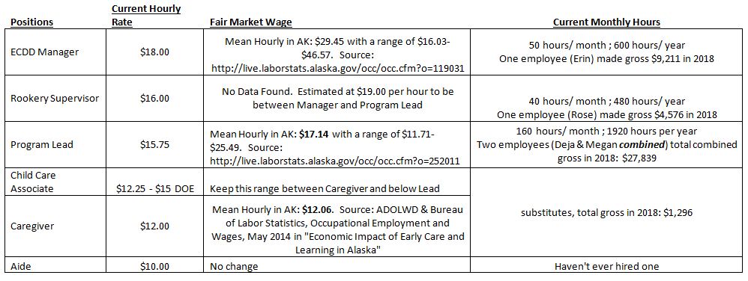

**Proposed Positions with updated starting hourly wages in 2024**

* Rookery Administrator $25 – technical administrative duties, communicates frequently with board, president as point of contact, on site 20 hours a week minimum (per licensing), works directly with children, works directly with program coordinator,
* Child Care Associate (Lead) $18 – on site child care provider, works under admin and program coordinator, and is largely responsible for executing day to day
* Child Care Associate (Other) $16.50 – on site child care provider, works under lead CCA to facilitate day to day
* Bookkeeper $25 – works independently, on site in off hours or from home at board's discretion, may take on administrative duties or hold both positions at boards direction
* Program Coordinator $25 – creates and oversees all programming, with board oversight and staff input and buy in
* Food Program Facilitator $25 – responsible for ordering, stocking, menu planning, and execution of menu by staff. this position may be an on-site cook as well, depending on negotiated position when hire, needs of the Rookery, etc. position can be held in tandem with another position as convenient and necessary